JSP and Servlets

Java code embedded in HTML code
More HTML code and less java code
Simplify the dynamic presentation layer in a multi-tiered architecture
Separate presentation and business logic
Template based content generation-JSP
Programmatic content generation-Servlets

Three types of predefined tags:
Directives
Scripting Elements
Actions
Custom tags

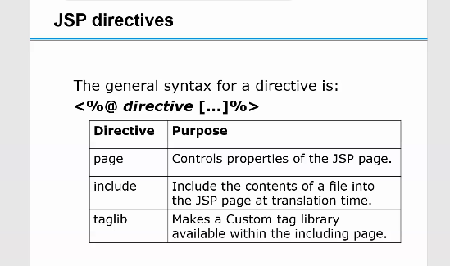

URL- Protocol Servername filepath
http (default port)
default port 80
https (default secure port)
default port 443 (HTTP on SSL)
HTTP runs on top of TCP/IP protocol
First specified in 1990
Current version is HTTP/1.1
Absolute and Relative Paths (absolute off context root)

Discrete connections
Server closes TCP/IP socket connection after processing a client request
Client can also close a connection
eg: Pressing the Back or Forward button in a browser
Each client request is handled in a discrete connection
Features of Stateless Connections:
server can accommodate a number of clients exceeding the number of server threads (http:// versus ftp:// --> sorry, limit of 100 ftp users!)
No server overhead associated with tracking client sessions between connections
Keep-Alive specification default in HTTP/1.1

Request- Method Request-URI Protocol
Eg. GET /index.html HTTP/1.1
Response- Protocol Status-Code Description
Eg. HTTP/1.1 200 OK
Every response contains a status code. Common ones are:
100 level: Informational
200 level: Success (200 == OK)
300 level: Redirection
400 level: Client Error (401 == BAD REQUEST)
500 level: Server Error (503 == SERVICE UNAVAILABLE)

Content Type is also known as MIME (Multipurpose internet Mail Extension) Type. It is a HTTP header that provides the description about what are you sending to the browser.
There are many content types:
text/html
text/plain
application/msword
application/vnd.ms-excel
application/jar
application/pdf
application/octet-stream
application/x-zip
images/jpeg
video/quicktime etc.

Allows the user to pass information to the server
All parameter information is stored in the body of the request rather than in the URL, which provides for more privacy
No set limit on the amount of information that can be passed as there is with the parameter passing of a GET
A POST is typically generated by the browser in response to a click on a Submit button on an HTML form that declares the POST method
POST /login.html HTTP/1.1
User-Agent: Mozilla/4.50 [en] (WinNT; I)
Accept: image/gif, image/jpeg
Content-Length: 34
CRLF
user=mark&password=secret

Most common method used to request a read only resource from the server, such as a static HTML page
May contain a If-Modified-Since header field, in which case it becomes a conditional GET, only if the target has been modified since the datestamp in the If-Modified-Since field
Parameters are stored in the URL itself:
GET /index.html?user=mark&password=secret HTTP/1.0
GET method is used to send form data,results from a database query, etc
The information is appended to URL
The total length of characters in GET method is confined to 240 characters only, by some servers

service ( ) :
Serving the client requests
Delegation of requests to appropriate methods
destroy ( ) is called at servlet unloading
Free the resources and do cleanup tasks
Make state persistent
SingleThreadModel : Tag interface to indicate that the service method will not be executed concurrently by two threads, This interface is deprecated from servlet specification 2.3

The init ( ) method :
Called by server on loading of the servlet
Called before the servlet handles it’s first request
Accepts a ServletConfig object that contains the initialization parameters
If overridden, must call super.init( config ) first
e.g. A counter for servlet calls

The notion of servlet context is closely associated with the notion of a web application
The interface javax.servlet.ServletContext allows servlets in an application to share data
Using ServletContext object, a servlet can log events, obtain URL references to resources, and store attributes that other servlets in the context can access

By making use of ServletConfig object servlet can get the configuration environment in which it is working
The Servlet API provides various means of accessing the ServletConfig object associated with the servlet
ServletConfig provides access to certain initialization parameters that can be configured while deploying the servlet

